The Beach House at Crystal Beach

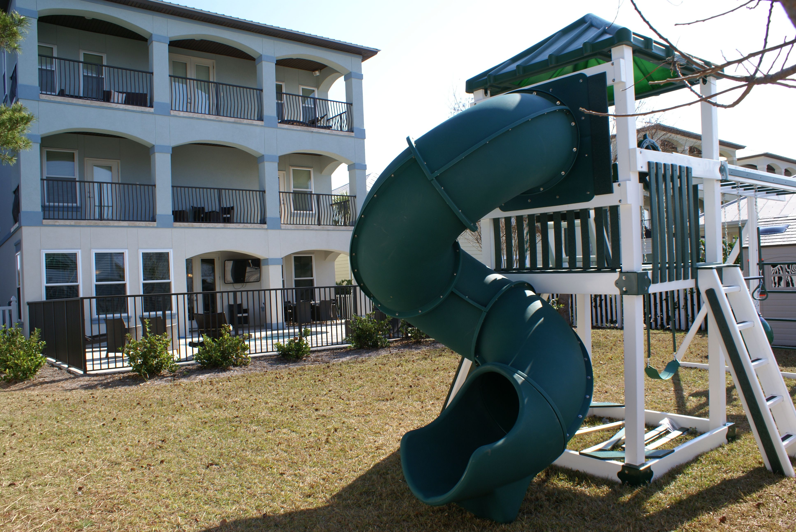

Property Guide Book



***Please leave this book at the property for future guests***

Access The Home

Welcome to the Emerald Coast! You have been assigned your personal door code that allows entry to the home any time during your reservation period from 4:00 pm on your day of arrival until 10:00 am on your day of departure.

Arrival Inspection

If the property is not cleaned to your satisfaction upon arrival, please let us know immediately. We will have it recleaned that day. It must be reported to us on the day of arrival in order for a no-charge cleaning to be accomplished.

If you notice any maintenance issues at the home please let us know via email or if time critical via phone.

During Your Stay

***Important***

- Please bring trash containers to curbside with lid opening toward street on MONDAY AND THURSDAY EVENINGS (pickup is the next morning). If this isn’t done you may run out of room in the cans and if they are full upon your departure we will have trouble getting the home ready for the next guests and will have to find some way of disposing of the trash. Thank you for your help with this!
- Please keep doors and windows closed when a/c is running or condensation will build up in the vents and drip down the wall which can damage the sheetrock.

Emergencies: Please contact us immediately if you notice any of the following:
- leak
- fire
- gas smell
- alarm beeping
- a/c or heat not working
- unable to access property
- water leak
- roof leak

Supplies: bath towels, kitchen towels, and linens are supplied; beach towels are not; an initial supply of the following are provided: kitchen paper towels, kitchen soap and dishwashing detergent, kitchen trash bags, laundry soap (use only high efficiency soap), toilet paper, bath body wash, makeup remover.

Outdoor Gas Grill: Please keep clean and do not damage concrete in the adjacent area. See FAQ for information on the propane tank.

Swimming Pool: The renter accepts all risk of the pool and specifically agrees that no minor will swim in the pool unaccompanied by an adult.

Elevator: Please carefully follow the below instructions for the safety of your party and to prevent a $150 maintenance fee. Failure to comply with these precautions could result in malfunction of the elevator and injury:
- ALWAYS HAVE A CELL PHONE WITH YOU WHEN USING ELEVATOR IN CASE IT WERE TO JAM WITH YOU INSIDE OF IT!
- If you cannot open the door after you are sure it is stopped on the desired floor, there is a latch up near the top of the door that you can push to manually open the door.
- Do not let children under the age of 18 use the elevator unsupervised
- Before boarding the elevator, make sure all shaft exterior doors are closed on every floor. If not properly closed, the door will not automatically lock itself into position and will not reopen without maintenance personnel.
- Press the “call” button next to the elevator door and wait for the light to turn green. This indicates the elevator has arrived and is ready for boarding.
- Once inside elevator, you must close exterior door first followed by the interior door. This is important! Interior doors have magnetic strips that connect to the door frame. Firmly close interior door and gently pull to make sure the door is in locked position. Next, slect the desired floor.
- After waiting to arrive, exit the elevator by opening the interior door followed by the exterior door. Remmber to close the interior door when you exit before you close the exterior door! The elevator will jam and will require maintenance to reopen.
- WAIT FOR ELEVATOR TO COME TO A COMPLETE STOP. IF DOORS ARE OPEN PREMATURELY THE ELEVATOR WILL COME TO A COMPLETE STOP BETWEEN FLOORS!
- If the elevator fails to start or jams during operation, please call us for mx.

Property Rules

- No food or drinks in the bedrooms
- Trash must be removed from the home and cans placed at the curb on Monday and Thursday evenings.
- Do not leave the a/c on with the doors/windows open. This will cause the units to freeze and stop working.
- Be respectful of other guests staying in the neighboring houses. Quiet time is 10:00 pm – 7:00 am, in conjunction with Okaloosa County noise ordinances. If the police come to the home more than once due to a violation of Destin’s noise regulations or for any other violation of law, you will be asked to vacate the property and your rental will be terminated.
- Do not leave anything on the beach overnight. The beach patrol will take anything left overnight and you will be charged.
- Please treat this home as you would your own. The homeowner has supplied everything in the home for your convenience. Please leave everything you find in the home for the next guests.
- NO SMOKING! This is a non-smoking home. Smoking in the home will result in a fee for removing the smell from the home. If you smoke outside, please make sure that all windows and doors are shut and remove cigarrette butts.
- No tents are allowed on the beach

Departure
- Check-out is 10:00 A.M. Unfortunately, we cannot make exceptions to this. Time is needed to prepare the property for the next guests.
- Prior to departing the home please accomplish the following:
* Please remove trash from all trash cans and place in the large green cans at the front of the home
* Remove all food items from the refrigerator and anywhere else food was stored.
* Ensure all dishes and cookware are clean
* Return any furniture that was moved back to its original position.
* There is no need to “strip” beds or “pile” towels when leaving unit.
* Please be sure all bikes are in the storage shed and secure the cable locks and the door padlocks.
* Lock all doors upon departure
- This is our home and we hope that you would treat it as you would your own. If the home is not left in the condition described in this checkout procedure, there are lost or damaged items, or it’s condition requires our housekeepers to do a deep cleaning, there will be an extra charge added to your bill. Thank you for your help taking care of our home!
Report Damage: With your rental you have purchase property damage insurance that may or may not cover damage depending on the nature of the damage, how it occurred, and if damage is reported upon your departure. If reported, it will likely be covered by your damage insurance, but if discovered after your departure it may not be.

Maintenance FAQ

Empty Propane Tank – If your tank is empty there is a spare one located in the bike shed. Please let us know if you have switched them out.

Refrigerator not cooling – It can take 12 hours to cool if just stocked up. Make sure the refridgerator and freezer are set at the mid cooling range

My electric is out in part of the house – Have you reset the GFI switch (a little button on one of the outlets usually in the bathrooms or kitchen)? Have you checked the breaker box for any tripped breakers?

My water is not hot enough – We ensure that all hot water heaters are set to the optimal temperature. While this large home has a 3 hot water heaters (one on each floor) you may need to allow time between showers, running the dishwasher, etc. for the water to fully reheat.

Air conditioning is not cooling and/or vents dripping condensation – Make sure it is in the “cool” position, on the auto setting, and set no lower than 70 degrees. Make sure all doors and windows are shut as this can cause the humidity level inside to rise and the unit to freeze.

We have no ice – The ice bin has been emptied for sanitation. Ice will take 12-24 hours to produce.

Pool Alarms – The home alarm system is set to “door chime” and there is a pool alarm in the home on the back door for the security of small children; PLEASE DO NOT CHANGE THIS SETTING AS A FUTURE GUEST THEN MIGHT NOT HAVE THIS PROTECTION.

Garbage disposal does not work – push the reset button located on the disposal underneath the sink.

Smoke detector is beeping – Are you cooking? If so, turn on the fan in the kitchen or open a door/window (continuous intermittent beeping indicates a low battery; please let us know)

We do not have enough towels – the property is adequately stocked with 2 sets of towels per occupant. A washer/dryer is located on the second and third floors for your use if you need to refresh supply.

Pool not warm enough – The pool will only heat to approximately 10 degrees warmer than the air temperature. Pools will not reach the temperatures approaching those of a hot tub. Water must be kept ½ way up the skimmer to maintain operation. If low, please use garden hose to fill.

Trash – Destin trash pickup is on Tuesday and Friday mornings. Cans must be placed at edge of street night before for the trash trucks to pick up. Please bag all trash before it goes into the cans. A CLEANING FEE will be assessed if you dump loose food/garbage into the trash cans.

Keyless locks – If your ode is not working, please make sure the green light flashes after each number. If the red light comes on, please wait until it stops before trying again. I f the wrong code is entered, wait 1 minute before re-entering. If the red light and green light alternate flashing, battery needs replacing; please contact us right away.

WiFi (Network name: Network05 password: royaltomato752)
1. Unplug the modem (located in the living room) and the router (located in the closet of the center, south facing room on the 2nd floor). Leave both unplugged for 30 seconds.
2. Plug modem in and wait for blinking lights to stop (about 2 min).
3. plug router in.
4. Run a search on the computer for the network name (netgear05)
5. Input password
6. If it still doesn’t conect, push and hold the small reset button on the back of the router for 30 seconds.
7. The router is now factory reset and the name of the router is defaulted to Netgear
8. If you still cannot connect let us know and we will work on it for you.

Emergency Maintenance

Please email Eric at Blue World Properties: BlueWorldProperties@earthlink.net

If time critical, please call Eric at Blue World Properties: 850-305-3677

If you don’t receive a response as soon as needed from Eric please call Holly Hawn at Blue World Properties: 850-225-1953

All else fails phone numbers if having trouble reaching the above: Kathy at 850-305-3676 or Bobbie Jo (or Tomassa) at 850-243-8124

Electronics

TV Instructions:

1. Inputs: Cable TV – HDMI3

2. To watch Cable TV – using the universal remote:
a. Press green power button at the top of the remote and this will turn on your TV, Cable Box, and AV receiver.
b. If one of the following 3 devices do not turn on, or you need to control a device separately: press the yellow MAIN button located in the center of the remote just below the LCD screen, next select the button beside the device you want to activate the main screen on (TV, receiver, cable) and this will pull up a menu on the remote for each device with different options (power on/off, iPod, fm, etc. depending on which device menu you have up on the universal smart remote screen). Next use the buttons located just below the LCD screen to control functions of the cable box (volume, channel, menu, etc.)

3. To listen to music – using the universal remote:
a. Press the yellow MAIN button and select Receiver
b. Next select which input you want to listen to (fm, iPod, cable)
c. You can either listen to the FM or iPod by iteself or listen and watch cable TV by itself.
d. Once you select FM it will change the TV to the FM controller and you will not be able to view cable TV until you select the CBL/SAT input again.

Other Information

Parking: Please park only in the driveway or in the garage of the property. Do not park on sidewalks, on the grass, or on any other adjacent properties. This may result in your vehicle being towed.

Parking a trailer or RV: These are not allowed to be parked in the Crystal Beach neighborhood, please contact us and we can provide a nearby location to park these.

Boat Slip: We can provide a boat slip in nearby Joes Bayou with easy access to Crab Island and the Inlet and bays. The fee is $2/foot/night and includes power and water.
Other Notes:
  - High-speed Internet access is available through the wired Ethernet ports or the wireless network; password is in the house guide above and also printed on the front of the modem in the second floor side room (South facing room) closet.
  - The Bikes are located in the storage shed in the backyard. They are secured by padlocks on the shed door and also cable locks; all with combination 9611. There are 3 black and 2 white Electra Townie beach cruisers and an Electra Sparker kids beach cruiser all purchased new in 2014. These are high quality bikes in excellent condition; please treat with TLC and always store in the shed when not in use and use cable locks when leaving unattended. All have adjustable seats. More bikes can be rented about a block away at the Beachside Inn Bike Rental at the end of the street and across from the beach access.
  - To get to the beach, walk south on Woodward Street then to one of the two beach access locations just to the left or right of Woodward on Scenic Hwy 98. You can also park at the beach access if you prefer or to drop off beach items.
  - Sleeping arrangements: 8 king suites, a bunk room with 4 twin bunks, a queen sleeper sofa on the second floor landing and in the first floor living room. There is a Pack-n-play crib located in the closet on the second floor landing. If used, bedding for the sleeper sofas are located in the common area closets on the 1st and 2nd Floor.
Address Book And Things to Do:
- The Beach House: 96 Woodward Street, Destin, FL 32541 House phone is 850-424-3911
- Beachside Inn Bike Rental: 2931 Scenic Highway 98, Destin, FL 32541 (888) 232-2498 (bike rental at end of street)
- Camille’s at Crystal Beach: 2931 Scenic Highway 98, Destin, FL 32541 (850) 337-8860 (great restaurant/bar at the end of the street)
- Camille’s Beach Bar and Coffee Shop: ground level below Camille’s Restaurant, opens 7:00 am
- Henderson Beach Inn: 2700 Scenic Highway 98, Destin, FL 32541 (850) 269-8646 (Fine Dining; one of Destin’s best restaurants, turn right at end of street and it is about 2 blocks where Scenic Hwy 98 ends). Reservations usually required.
- The Outback Steakhouse, Destin: 34908 Emerald Coast Pkwy, Destin, FL 32541 (850) 269-1936 (2 minute walk north toward Hwy 98)
- O'Quigley's Seafood Steamer & Oyster Sports Bar: 34940 Emerald Coast Pkwy, Destin, FL 32541 (850) 837-1015
- Also nearby an easy walk or drive to the north (away from beach) are all of the shops and restaurants of the Destin Commons district shopping including the Hard Rock Café, Bonefish Grill, Chili’s Restaurant, Sonic Drive In, TGI Fridays, Barnes and Nobles Books Store (and Starbucks), and many other retail and food establishments including the AMC 12 Movie Theatre and all of the great shops at The Destin Commons
- Big Kahunas Water Park: 1007 Hwy 98 E, Destin, Florida 32541 (850) 837-4061
- The Track Recreation Center: 1125 U.S. 98, Destin, FL 32541 (850) 654-4668 (arcade, go-carts, bumper boats, miniature golf, and lots of other rides and activities for all ages)
- Fat Daddy’s Arcade and Pizza: 20009 Emerald Coast Pkwy, Destin, FL 32541 (850) 424-6021
- FudPuckers Restaurant and Bar: 20001 Emerald Coast Pkwy, Destin, FL 32541 (850) 654-1544 (Fun place; good prices; often live music)
- 790 On The Gulf: 2996 Scenic Highway 98, Destin, FL 32541 (850) 650-4853 (beachfront fine dining; incredible location; good New Orleans style food; located ground floor of The Inn at Crystal Beach Condos)
- The Crab Trap Restaurant: 3500 Scenic Highway 98, Destin, FL 32541 (850) 654-2722 (Casual and fun Beachfront Dining with Beachfront Bar and ice cream shop)
- Pompano Joes Restaurant and Bar: 2237 Hwy 2378, Destin, FL 32550 850-837-2224 (Casual Beachfront Food and Bar, live music outside some nights).
- Jimmy Buffet’s Margaritaville, Destin: 76 Harbor Blvd, Destin · (850) 460-7700 (Jimmy Buffet’s latest restaurant and now in Destin with a beautiful location on the harbor; great place to watch the sunset; large and nice restaurant and several bars; located in Harborwalk Village)
To find other things to do in Destin including dining, shopping, and others we recommend the official Emerald Coast Visitor’s Website:
http://www.emeraldcoastfl.com


The Beach House at Crystal Beach
Destin, FL

Property Guide Book

